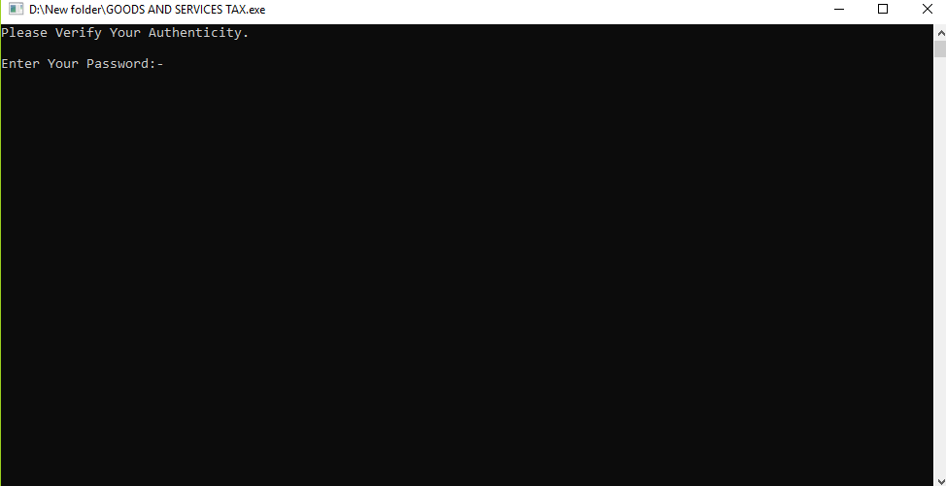

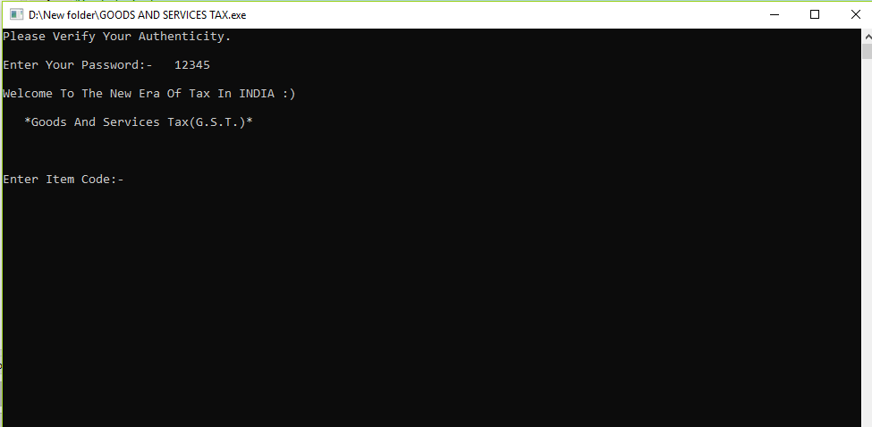

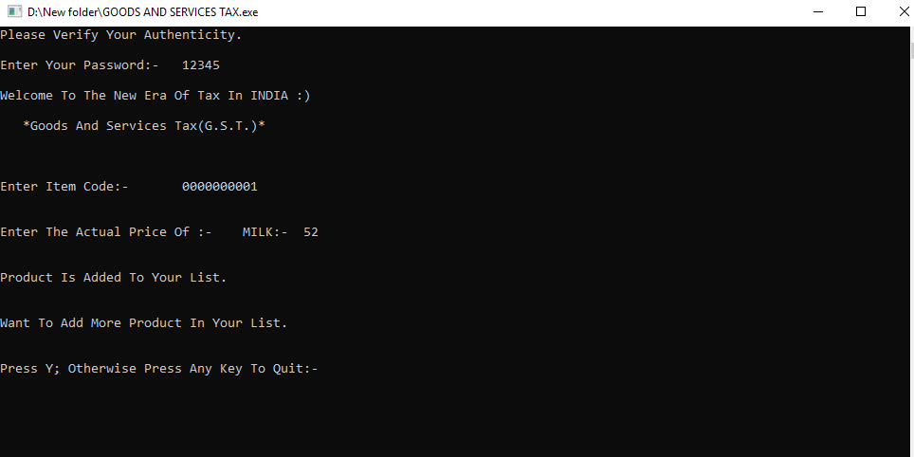

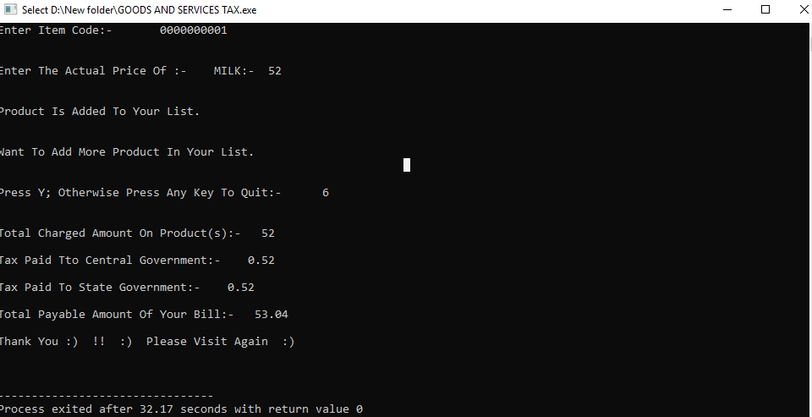

COMPUTER SCIENCE PROJECT

**TOPIC: GOODS AND SERVICES TAX**

MADE BY: ABHAY PORWAL

CLASS: 12th E

KENDRIYA VIDYALAYA

TUGHLAKABAD,NEW DELHI

BOARD ROLL NO. :-

AISSCE:- 2018-19